**Sawyer project- Understandable Robot Using ChatGPT**

**Group1-statistical analysis Results-scenario 1+2-Subjective measures:**

**1.Explanation Satisfaction Scale (average):**

**Shapiro-Wilk test for normality:**

**#For Adaptive Dialog (Adaptability = 1):**

shapiro.test(data$Explanation_satisfaction_Scale[data$Adaptability == 1])

W = 0.97575, p-value = 0.7902

**Conclusion**: p-value>0.05 , The adaptive Dialog follows a normal distribution.

**# For Non-Adaptive Dialog (Adaptability = 0):**

shapiro.test(data$Explanation_satisfaction_Scale[data$Adaptability == 0])

W = 0.97344, p-value = 0.7327

**Conclusion**: p-value>0.05 , The Non-AdaptiveDialog follows a normal distribution.

**Mixed-effects model for Explanation Satisfaction**

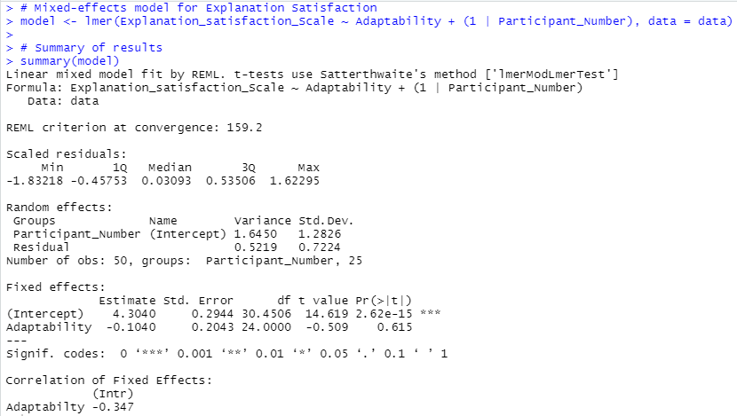

**Anova:**

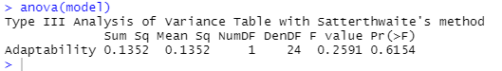

**Conclusion:** The p-value for **Adaptability** is **0.615**, which is well above the significance threshold of **0.05**. This means the **effect of Adaptability** on **Explanation Satisfaction** is **not statistically significant**.

**2. Trust Scale (average):**

**Shapiro-Wilk test for normality:**

**For Adaptive Dialog (Adaptability = 1):**

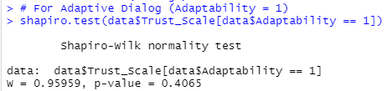

**Conclusion**: p-value>0.05 , The adaptive Dialog follows a normal distribution.

**For Non-Adaptive Dialog (Adaptability = 0):**

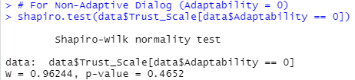

**Conclusion**: p-value>0.05 , The Non-AdaptiveDialog follows a normal distribution.

**# Mixed-effects model for Trust Scale:**

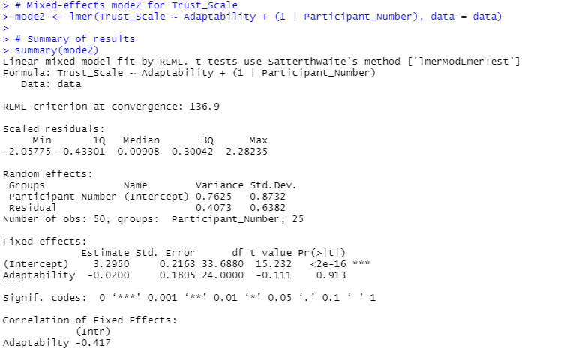

**Anova**:

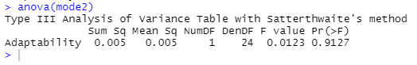

**Conclusion:** The p-value for **Adaptability** is **0.913**, which is above the significance threshold of **0.05**. This means the **effect of Adaptability** on **Trust Scale** is **not statistically significant**.

**3. Fluency of Interaction (average):**

**Shapiro-Wilk test for normality:**

**For Adaptive Dialog (Adaptability = 1):**

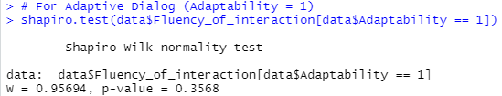

**Conclusion**: p-value>0.05 , The adaptive Dialog follows a normal distribution.

**For Non-Adaptive Dialog (Adaptability = 0):**

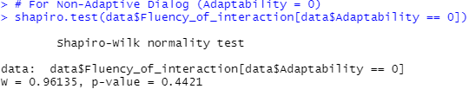

**Conclusion**: p-value>0.05 , The adaptive Dialog follows a normal distribution.

**Mixed-effects mode3 for Fluency of interaction**:

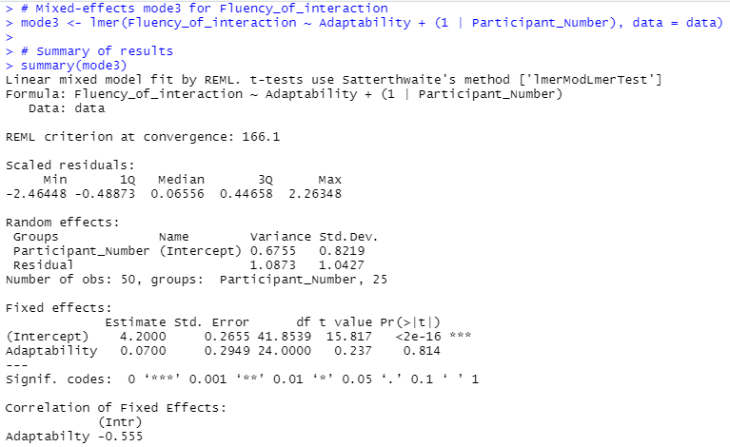

**Anova**:

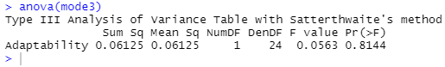

**Conclusion:** The p-value for **Adaptability** is **0.814**, which is well above the significance threshold of **0.05**. This means the **effect of Adaptability** on **Fluency of interaction** is **not statistically significant**.